Creating IAM Roles

Lab Details:

1. This lab walks you through the steps to Create IAM Roles.
2. Duration:**30 minutes**
3. AWS Region: **US East (N. Virginia) us-east-1**

Architecture Diagram:

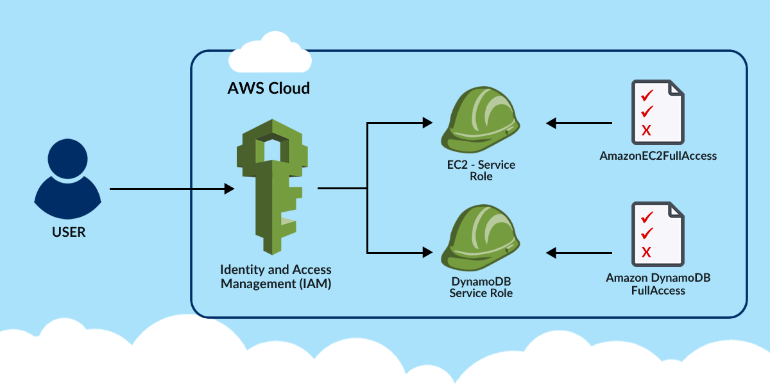

Task Details:

1. Log into AWS Management Console.
2. Create IAM Role for EC2 service
3. Create IAM Role for DynamoDB service.
4. Validation of the lab